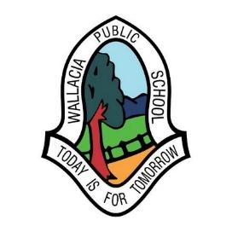
Wallacia Public School
PARENTS & CITIZEN ASSOCIATION
1573-1585 Mulgoa Road
WALLACIA NSW 2745

Change of date for disco!
Wallacia PS P and C will be hosting a school disco on Wednesday 29th June.
Doors open: 5:20pm
Music Starts: 5:30pm
End time: 6:30pm
Tickets are $5 each and each ticket will include on the evening, a popper, packet of chips, something sweet and a glow stick.
Please return the below slip with $5 in an envelope by Monday 27th June, 9:00am, in the orange P&C box located in the school office.
We welcome parents to stay with us whilst the disco is in progress for a sausage sizzle and a chat.
We hope to see you all there in your best dressed with your best dance moves.

Regards,
Wallacia Public School P and C

Enclosed is $5 for ____________________ (child’s name) from __________ (class)
I _________________________ (parent’s name) am aware that I will need to pick up my child at the end of the disco at 6:30pm.

