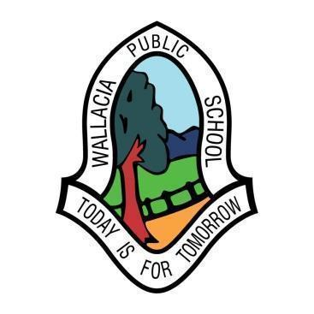
WALLACIA PUBLIC SCHOOL
1573-1585 Mulgoa Road
WALLACIA NSW 2745
Tel: 4773 8433
Email: Wallacia-p.school@det.nsw.edu.au

Rel Principal: Mrs Michele Van Vliet
_____________________________________________________________________________
27 June 2022

Industrial Action

Members of the NSW Teachers Federation will be taking industrial action Thursday June 30, 2022 in the form of a 24 hour strike.

SCHOOL WILL BE OPEN

Wallacia Public School will be operational for all students on the day of the strike.
All teachers will be onsite and classes will be as per normal. This is a NORMAL school day at Wallacia PS.

Wig Wam will also operate as per usual operating hours.

Kind regards,
Mrs Michele Van Vliet
Rel. Principal

